Written By: Aidan Jacobsen
Date: 4/11/2024
How To Select a Project
Purpose: The purpose of this document is to explain how to load a project onto the STARS chip on a Linux OS (such as Windows Subsystem for Linux).
Estimated Time to Complete Tutorial: 1 hour (~5 minutes for subsequent project configurations)

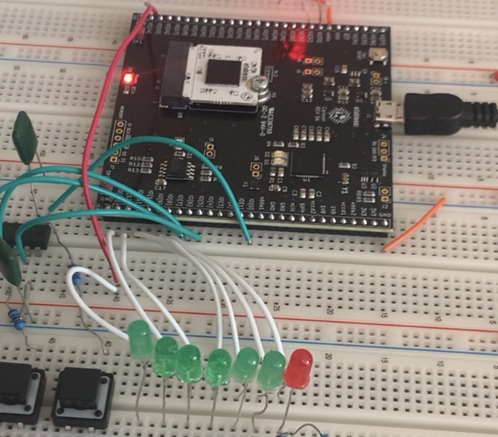
Step 1: Solder Efabless breakout board ensuring that pins will align with breadboard holes
Step 2: Wearing an ESD band, connect the STARS NEBULA chip to the breakout board’s M.2 Connector at a 30 degree angle in the top slot. Press down and secure with provided screw.
Step 3: Connect Efabless breakout board to computer using a data-transfer-capable Micro USB cable. The default blink program should start.
Step 4: Ensure python library ‘pyftdi’ (pip3 install pyftdi) is installed. Note that this requires Linux so far (you may be able to get it to work in windows, but the libusb dependency isn’t supported for Windows).
Step 5: Within the Project Binaries folder, start a python instance and run the following, replacing # with your team number from the table on the next page. If you are running this in WSL, you will need to use usbipd in command prompt to bind and attach the USB port (--busid) of the board. See the ‘Compiling Binaries’ tutorial for more details.
python3 caravel_hkflash.py load#.hex

Team 1 | Absentees
Team 2 | DiggiDoggs
Team 3 | EightyTwos
Team 4 | Geriatrics
Team 5 | GuitarVillains
Team 6 | MatrixMonSTARS
Team 7 | Outel
Team 8 | SaSS
Team 9 | Silly Synth
Team 10 | SynthSTARS
Team 11 | SynthSurgeons
Team 12 | Teenage Mixing Ninja Turtles
Table 1: Table showing the team names for each of the compiled binaries.

